**REPORT**

Zajęcia: Analog and digital electronic circuits

Teacher: prof. dr hab. Vasyl Martsenyuk

**Lab 2**

13.03.2025

**Topic:** "Spectral Analysis of Deterministic Signals"

**Variant: 13**

Rafał Żmuda

Informatyka II stopień,

stacjonarne,

1 semestr,

Gr.2b

1. **Problem statement:**

Generate three sine signals of given f1, f2, and f3 and amplitude |x[k]|max

for the sampling frequency fs in the range of 0 ≤ k < N.

Plot: 1 1. the "normalized" level of the DFT spectra. 2. the window

DTFT spectra normalized to their mainlobe maximum

**2. Input data:**

f1 = 500,

f2 = 500.25,

f3 = 499.75,

x[k]max = 4

fs = 800

N = 1800

**3. Commands used (or GUI):**

1. **Part 1of the assignment DFT spectrum**

* Source code

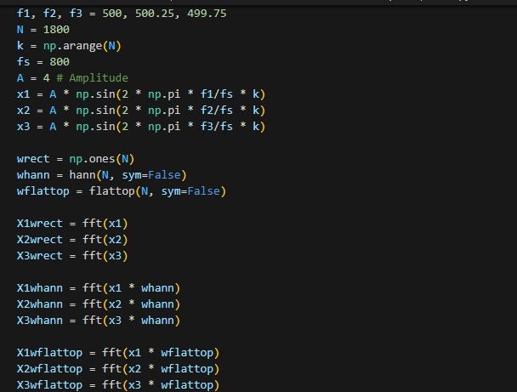

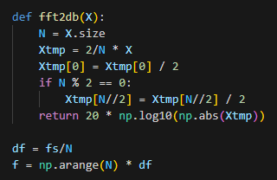

* Outcomes:

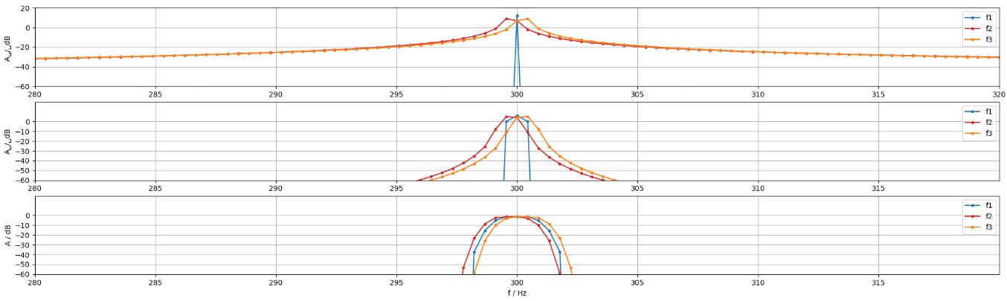

1. **Part 2 of the assignment DTFT spectrum**

* Source code

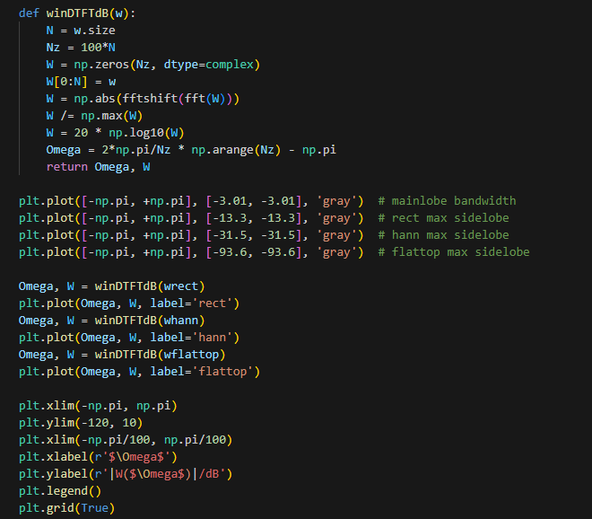

* Outcomes:

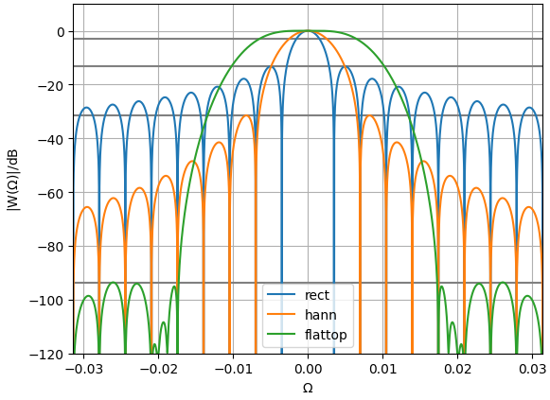

Link to remote repository: https://github.com/RafalZmu/School

**5. Conclusions:**

The different window functions show clear trade-offs in spectral analysis. The rectangular window provides the best frequency resolution with its narrow main lobe but suffers from high spectral leakage as shown by the jagged side lobes. The Hann window offers a good compromise with reduced side lobes but a slightly wider main lobe. The flattop window sacrifices frequency resolution (widest main lobe) but provides the most accurate amplitude measurements with minimal side lobes.

The differences between f1 and f2 are most apparent with the rectangular window because f1 (300Hz) aligns almost perfectly with a DFT bin while f2 (299.75Hz) falls between bins. This causes the "scalloping effect" where frequencies not aligned with bins experience amplitude reduction. The Hann window reduces this difference somewhat, while the flattop window almost eliminates it entirely as it's specifically designed for accurate amplitude measurements regardless of bin alignment.